Put the steps in the correct order to preform adult CPR (8 years of age and up). Please remember that during a pandemic it is not safe to jump in and start first aid. Even the basic first aid PPE (personal protective equipment) may not be enough. Your personal safety is most important. We want you to help! If you suspect COVID: Check your environment. Keep your distance and call 9-1-1. The paramedics have more appropriate PPE.
Unscramble the steps to CPR
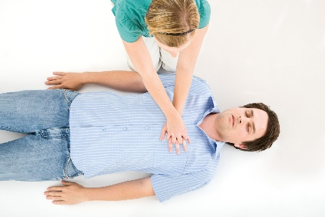

- Activate Emergency Medical Service
- Landmark
- Attempt to obtain PPE (gloves and pocket mask)
- Attempt to obtain an AED and recruit AED-trained responder if available
- Continue until EMS tor the takes over, or AED trainer responded begins treatment with AED, or victim moves
- If breathing is absent or abnormal, start CPR
- Visual Check, breathing check
- 30 Compression (in 15-18 seconds, depth is 5-10cm)
- Assessment of Environment
- Open airway: head-tilt/chin-lift
- If victim begins to move, assess ABC’s and treat appropriately
- Establish unresponsiveness

